*A review should not exceed* ***8,000 words****, including the abstract, main text, table titles and contents, figure captions, reference list, and translated sections.*

УДК 000.00:111.11

Review / Обзор

**Title of the Review in English**

**Elena V. Ivanova1,**🖂**, Maria A. Petrova1,2, Marina N. Smirnova1, Vasily G. Sidorov2**

1Scientific Centre for Expert Evaluation of Medicinal Products,

8/2 Petrovsky Blvd, Moscow 127051, Russian Federation

2 Lomonosov Moscow State University,

1/3 Leninskie Gory, Moscow 119991, Russian Federation

🖂 **Elena V. Ivanova** [ivanova@expmed.ru](mailto:ivanova@expmed.ru)

**ABSTRACT** *The abstract should not exceed 150–300 words.*

**INTRODUCTION.** The introduction should provide a brief description of the knowledge gaps in the field and the possible ways to address the research problem (1–2 sentences).

**AIM.** This section of the abstract should include a clear and comprehensive statement of the research question. This statement should unambiguously present the study idea and the possible results the authors would like to achieve. The wording of the aim in the abstract should coincide with the wording in the main text of the article.

**DISCUSSION.** This is the most extensive section of the abstract, which presents important information from each section of the article. The discussion should contain specific data, so that the reader could understand what exactly the authors have identified, discovered, or established through their review of scientific literature or regulatory documents. The authors should not simply list previous studies; instead, they should present a critical review, summarise the main points of view on the matter, and express their own perspectives on the results of previous studies.

**CONCLUSIONS.** The conclusions should summarise the main results of the study. This section should correspond to the aim and objectives of the study as closely as possible, show that the aim has been achieved, outline directions for further research, and/or describe potential practical applications of the results obtained.

**Keywords:** 5–10 words or word combinations; specific to the study topic; supplementing the terms provided in the title and the abstract; separated by semicolons; specifying the review type (meta-analysis, narrative review, etc.); no full stop at the end

**For citation:** Ivanova E.V., Petrova M.A., Smirnova M.N., Sidorov V.G. Title of the review in English. *Biological Products. Prevention, Diagnosis, Treatment.* 2024;24(1):**–**.

## Funding. Here, the authors should either specify their funding sources or state that they conducted the study without external funding.

EXAMPLES:

**Funding.** The study was performed without external funding.

or

**Funding.** The study reported in this publication was carried out as part of publicly funded research project No. __________________ and was supported by the Scientific Centre for Expert Evaluation of Medicinal Products (R&D reporting No. ________________).

**Disclosure.** In this section, the authors should declare all personal relationships or interests that may directly or indirectly affect or bias their work (e.g. an author holds a patent for the method applied, an author is a member of the Editorial Board of *Biological Products. Prevention, Diagnosis, Treatment,* etc.). If there is no conflict of interest, the authors should report that as well.

EXAMPLES:

**Disclosure.** The authors declare having no conflict of interest.

or

**Disclosure.** Elena V. Ivanova has been a member of the Editorial Board of *Biological Products. Prevention, Diagnosis, Treatment* since 2021. The other authors declare having no conflict of interest.

or

**Disclosure.** The authors work for Bacteriophage AO. However, when writing this paper, the authors were guided by considerations of the scientific value of the material obtained; the authors declare their impartiality in its assessment.

**Title of the review in Russian**

**Е.В. Иванова1,**🖂**, М.А. Петрова1,2, М.Н. Смирнова1, В.Г. Сидоров2**

1Федеральное государственное бюджетное учреждение

«Научный центр экспертизы средств медицинского применения»

Министерства здравоохранения Российской Федерации,

Петровский б-р, д. 8, стр. 2, Москва, 127051, Российская Федерация

2Федеральное государственное бюджетное образовательное учреждение высшего образования «Московский государственный университет имени М.В. Ломоносова»,

Ленинские горы, д. 1, стр. 3, Москва, 119991, Российская Федерация

🖂 **Иванова Елена Владимировна** [ivanova@expmed.ru](mailto:ivanova@expmed.ru)

**РЕЗЮМЕ**

**ВВЕДЕНИЕ.**

**ЦЕЛЬ.**

**ОБСУЖДЕНИЕ.**

**ВЫВОДЫ.**

This section is for the abstract in Russian. When translating the abstract and keywords, the authors should adhere to industry-specific terminology. The authors should avoid transliterations, except for untranslatable proper names and names of instruments and other objects that do not have an exact equivalent in the target language. The abstract should be coherent and cohesive. In English, the active voice is generally preferred over the passive voice. For example, “The study tested the hypothesis” is preferable to “The hypothesis was tested in the study”. However, this preference does not apply to Russian texts. To ensure a clear and coherent presentation of their text, the authors may consider using such words and collocations as следовательно (consequently), более того (moreover), например (for example), преимущества данного исследования (benefits of this study), and в результате (as a result).

**Ключевые слова:** 5–10 words or word combinations; specific to the study topic; supplementing the terms provided in the title and the abstract; separated by semicolons; specifying the review type (meta-analysis, narrative review, etc.); no full stop at the end

**Для цитирования:** Иванова Е.В., Петрова М.А., Смирнова М.Н., Сидоров В.Г. Title of the review in Russian. БИОпрепараты. Профилактика, диагностика, лечение*.* 2024;12(4):**–**.

**Финансирование.** Работа выполнена без спонсорской поддержки.

or

**Финансирование.** Работа выполнена в рамках государственного задания ФГБУ «НЦЭСМП» Минздрава России № __________________ на проведение прикладных научных исследований (номер государственного учета НИР _______________________).

**Потенциальный конфликт интересов.** Авторы заявляют об отсутствии конфликта интересов.

or

**Потенциальный конфликт интересов.** Е.В. Иванова является членом редколлегии журнала «БИОпрепараты. Профилактика, диагностика, лечение» с 2021 г. Остальные авторы заявляют об отсутствии конфликта интересов.

or

**Потенциальный конфликт интересов.** Авторы являются сотрудниками АО «Бактериофаг». Однако при написании рукописи авторы руководствовались соображениями научной ценности полученного материала и заявляют о беспристрастности оценки полученных данных.

**INTRODUCTION**

The introduction should describe scientific relevance of the research topic (i.e. the degree of importance of this topic at this time and in this particular situation). The introduction should establish the research problem, show the scope of this problem, and describe initial hypotheses (if any). The authors should identify the research gap through a review of previously published data (in Russia and internationally). When explaining the importance of their research, the authors should include significant premises that prove the need to study the selected topic. The authors should answer why they conducted the review, what pressing issue they were trying to solve, and why it was necessary to study this problem at the very moment they did it.

The sources of all quotations should be clearly identified. All references to indexed sources (e.g. research papers and monographs) should be identified by consecutive Arabic numerals in square brackets (e.g. [1, 2], [3–7]). Non-indexed sources should be referenced in footnotes (MS Word’s Insert/Footnote function).[1] Non-indexed sources include but are not limited to theses and thesis summaries, educational and instructional materials, legal and regulatory documents (e.g. pharmacopoeia chapters and monographs), standards (e.g. GOSTs), guidelines and recommendations, websites, statistical documentation, scientific and technical documentation (e.g. R&D reports), etc. For further information on the format of footnotes and references, please see the Author Guidelines.

The introduction should not exceed 20% of the article.

It is required to end the introduction with a clear formulation of the aim.

The aim of a review should be to discuss the accumulated literature, present the authors’ perspective on previously described phenomena, reconsider existing approaches and search for new approaches to the interpretation and use of these phenomena.

To formulate the aim, the authors should answer the following question: What do they want to achieve as a result of the research? It is not acceptable to simply list the facts and describe the current state of research on the topic.

The aim statement should be clear, brief (one-sentence long), and unambiguous (i.e. not open to double interpretation). The aim should not contain abbreviations. In Russian, it is preferable to use nouns (e.g. evaluation, comparison, development) rather than verbs (e.g. to assess, to analyse, to evaluate). The authors formulating the aim in Russian might want to use such words as оценка, анализ, сравнительный анализ, разработка, анализ рекомендаций, выбор подходов, etc.

After the aim, the text should list all the searched databases, libraries, registers, etc.; the period covered by the search; the keywords and filters (if any); and the inclusion and exclusion criteria for the articles to be reviewed.

If the authors used AI-based software while preparing the review, they should specify the name and version of the software and provide the prompts they used.

**MAIN PART**

The main part of a review manuscript should cover relevant literature sources, summarise the obtained results, and provide recommendations for their practical application. When drafting the main body of a review, the authors should always keep their aim in mind.

The authors should describe the most significant ideas and results of previous studies, demonstrate the current understanding of the research problem, provide a critical assessment of the ideas under consideration, and identify potential patterns.

To structure the study material, the authors may divide their manuscript into **sections** and, if necessary, **subsections.** The sections should not be numbered.

Example:

**Section title**

***Subsection title.*** Subsection text.

**Section title**

***Subsection title.*** Subsection text.

A review should cover **not less than 25 publications**. It is recommended to quote up-to-date sources published within the last 5 years in Russian and other languages.

Reviewed materials may be presented as tables (*Table 1*) or figures (*Figs 1, 2*). For tables and figures, the titles, captions, contents, and notes should be provided in Russian and in English.

All the abbreviations used in a table or figure should be written out in full in the note for that table or the caption for that figure, even if this has already been done elsewhere in the text. When reproducing a published table or figure without changes, the authors should either reference the source published under CC BY (*Fig. 1*) or provide the Editorial Office with the copyright holder’s permission to reuse the material. When illustrating their own material with adapted data from published tables or figures, the authors should reference the sources in the title of their table (*Table 1*) or figure.

**Table 1.** Title of the table (adapted from A.A. Yarilin [2])

**Таблица 1.** Название таблицы (по А.А. Ярилину [2] с изменениями)

|  |  |  |
| --- | --- | --- |
| **Название графы 1**  ***Name of column 1*** | **Название графы 2**  ***Name of column 2*** | **Название графы 3**  ***Name of column 3*** |
| Текстовое содержимое ячеек  *Cell text content* | 0,25* | – |
| 1 | 3 |
| 6 | Соответствует  *Conforms* |

The table is prepared by the authors / Таблица составлена авторами

The table is reproduced from [1] licensed under CC BY / Таблица заимствована авторами из источника [1], лицензия CC BY

*Note.* If the table contains abbreviations, the abbreviations should be written out in full in the note to the table. If the table contains dashes, their meaning should be explained: –, no data (not applicable, not detected, etc.).

* Explanations for individual results in the table.

*Примечание.* Если в таблице использовались сокращения, то следует привести их расшифровку в примечании; если в таблице использовались прочерки, необходимо пояснить, что они означают; «–» обозначает отсутствие сведений (неприменимо, не обнаружено и т.д.).

* Пояснения к отдельным результатам в таблице.

Tabulated data should not duplicate the information given in figures, and *vice versa*.

The title and abbreviations for a figure should be provided in English and Russian and placed below the figure; no full stop at the end *(Figs 1, 2)*.

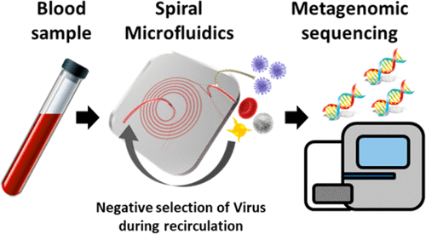

**1 2 3**

1 – обозначение; 2 – обозначение; 3 – обозначение

1, description; 2, description; 3, description

The figure is prepared by the authors **/** Рисунок подготовлен авторами

The figure is reproduced from [1] licensed under CC BY / Рисунок заимствован авторами из источника [1], лицензия CC BY

**Fig. 1.** Title of the figure in English [3]

**Рис. 1.** Название рисунка на русском языке [3]

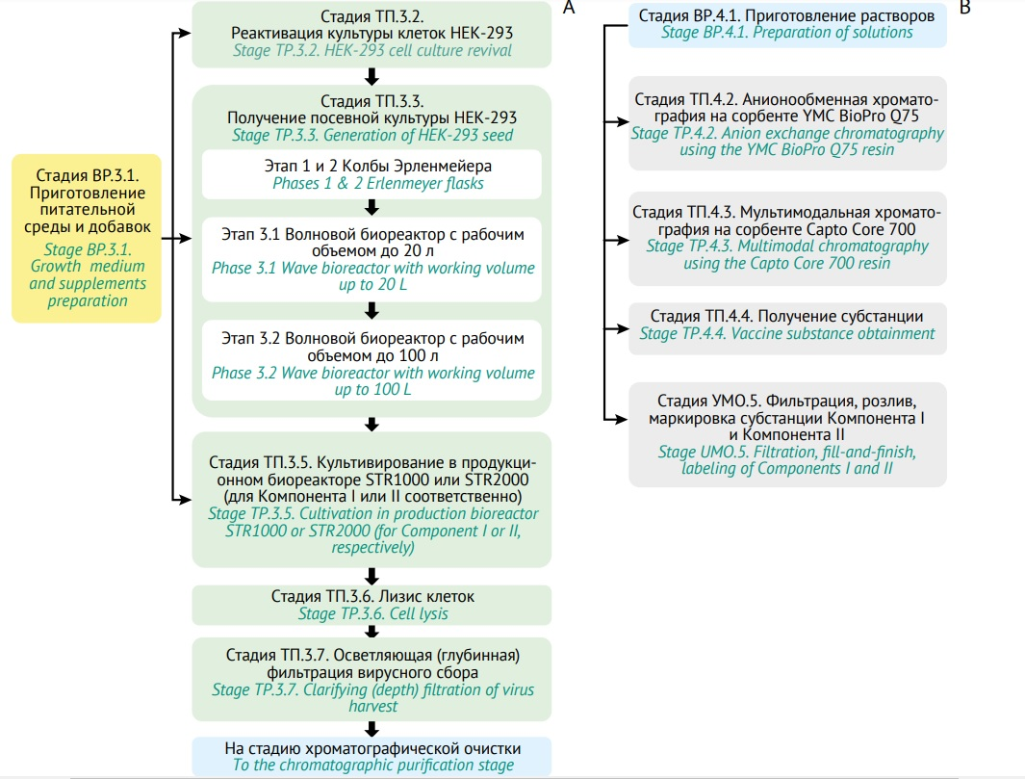

The figure is prepared by the authors **/** Рисунок подготовлен авторами

The figure is reproduced from [1] licensed under CC BY / Рисунок заимствован авторами из источника [1], лицензия CC BY

**Fig. 2.** Title of the figure in English

**Рис. 2.** Название рисунка на русском языке

**CONCLUSION**

The content of this section should correspond to the aim of the study and demonstrate that it has been achieved. The authors should briefly describe the results of the completed information analysis, reflecting its theoretical and practical significance; they should provide generalisations and recommendations. It is advisable to outline directions for further research in the field.

The conclusion should not repeat the text of the article word for word or reference any literature, as the authors should describe the results of their own analysis.

This section may be formatted as a numbered list of conclusions. In this case, its title should be changed to **CONCLUSIONS**.

**References / Литература**

1. Алпатова НА, Гайдерова ЛА, Яковлев АК, Мотузова ЕВ, Лысикова СЛ, Солдатов АА и др. Особенности определения специфической активности биотехнологических лекарственных средств. *Биопрепараты. Профилактика, диагностика, лечение.* 2017;17(1):13–26.

Alpatova NA, Gayderova LA, Yakovlev AK, Motuzova EV, Lysikova SL, Soldatov AA et al. Assessment of biotechnological products’ specific activity. *BIOpreparations. Prevention, Diagnosis, Treatment.* 2017;17(1):13–26 (In Russ.). EDN: [YHSSGL](https://elibrary.ru/yhssgl)

2. Prior S, Metcalfe C, Hufton SE, [Wadhwa](https://www.nature.com/articles/s41587-021-00848-0#auth-Meenu-Wadhwa) M, [Schneider](https://www.nature.com/articles/s41587-021-00848-0#auth-Christian_K_-Schneider) CK, [Burns](https://www.nature.com/articles/s41587-021-00848-0#auth-Chris-Burns) C. Maintaining standards for biosimilar monoclonal antibodies. *Nat Biotechnol*. 2021;39(3):276–280. <https://doi.org/10.1038/s41587-021-00848-0>

3. [Wadhwa](https://www.ncbi.nlm.nih.gov/pubmed/?term=Wadhwa%20M%5BAuthor%5D&cauthor=true&cauthor_uid=33936049) M, [Bird](https://www.ncbi.nlm.nih.gov/pubmed/?term=Bird%20C%5BAuthor%5D&cauthor=true&cauthor_uid=33936049) C, [Atkinson](https://www.ncbi.nlm.nih.gov/pubmed/?term=Atkinson%20E%5BAuthor%5D&cauthor=true&cauthor_uid=33936049) E,[Cludts](https://www.ncbi.nlm.nih.gov/pubmed/?term=Cludts%20I%5BAuthor%5D&cauthor=true&cauthor_uid=33936049) I, [Rigsby](https://www.ncbi.nlm.nih.gov/pubmed/?term=Rigsby%20P%5BAuthor%5D&cauthor=true&cauthor_uid=33936049) P. The first WHO international standard for adalimumab: dual role in bioactivity and therapeutic drug monitoring. [*Front Immunol.*](https://www.ncbi.nlm.nih.gov/pmc/articles/PMC8082443/) 2021;12:636420. <https://doi.org/10.3389/fimmu.2021.636420>

4. Schasfoort RBM. *Handbook of surface plasmon resonance*. 2nd ed. RSC Publishing; 2017. <https://doi.org/doi:10.1039/9781788010283-FP001>

5. Щелкунов СН, Сергеев АА, Кабанов АС, Якубицкий СН, Бауэр ТВ, Пьянков СА. Патогенность и иммуногенность вариантов вируса осповакцины при разных способах их введения мышам. Инфекция и иммунитет. 2021;11(2):357–64.

Shchelkunov SN, Sergeev AA, Kabanov AS, Yakubitsky SN, Bauer TV, Pyankov SA. Route-coupled pathogenicity and immunogenicity of vaccinia virus variant inoculated mice. Russian Journal of Infection and Immunity. 2021;11(2):357–64 (In Russ.). <https://doi.org/10.15789/2220-7619-PAI-1375>

6. Васин АВ, Егоров АЮ, Сергеева МВ, Стукова МА. Рекомбинантные векторные конструкции на основе аттенуированного вируса гриппа для разработки вакцин против респираторных инфекций. В кн.: [*III объединенный научный форум физиологов, биохимиков и молекулярных биологов*](https://www.elibrary.ru/item.asp?id=49822670&selid=49824067)*. VII съезд биохимиков России. X Российский симпозиум «Белки и пептиды». VII съезд физиологов СНГ*. Т. 2. Москва: Перо; 2021. С. 229–30.

Vasin AV, Egorov AYu, Sergeeva MV, Stukova MA. Recombinant vector constructs based on attenuated influenza virus for the development of vaccines against respiratory infections. In: *III Joint Scientific Forum of Physiologists, Biochemists and Molecular Biologists. VII Congress of Russian Biochemists. X Russian Symposium “Proteins and Peptides”. VII Congress of CIS Physiologists*. Vol. 2. Moscow: Pero; 2021. P. 229–30 (In Russ.). EDN: [SXYWDM](https://elibrary.ru/sxywdm)

7. Carlton RM. Phage therapy: past history and future prospects. *Arch Immunol Ther Exp*. 1999;47(5):267–74. PMID: 10604231

**Additional information.** The authors may provide a link to supplementary materials to the article (figures, tables, and other files), including those placed in a repository (with their digital object identifiers (DOIs)).

|  |  |
| --- | --- |
| **Authors’ contributions.** All the authors confirm that they meet the ICMJE criteria for authorship. The most significant contributions were as follows. ***E.V. Ivanova*** conceptualised the study, drafted the manuscript, formulated the conclusions, etc. ***M.A. Petrova*** worked with literature sources, etc. ***M.N. Smirnova*** drafted the manuscript. ***V.G. Sidorov*** participated in formulating the conclusions and approved the final version of the manuscript for publication. | **Вклад авторов.** Все авторы подтверждают соответствие своего авторства критериям ICMJE. Наибольший вклад распределен следующим образом: ***Е.В. Иванова*** – концепция работы, написание текста рукописи, формулировка выводов, и др.; ***М.А. Петрова*** – работа с источниками литературы, и др.; ***М.Н. Смирнова*** – написание текста рукописи; ***В.Г. Сидоров* –** участие в формулировке выводов, утверждение окончательной версии рукописи для публикации. |

**Acknowledgments.** The authors may use this section to thank others for their help with accessing databases, literature sources, etc. The authors may express gratitude to the colleagues who assisted in the study or provided critical feedback on the manuscript. However, the authors should first obtain permission from the people or institutions they would like to address.

EXAMPLES:

|  |  |
| --- | --- |
| **Acknowledgements.** The authors express their gratitude to I.I. Ivanov for valuable advice when discussing the study results, to City Hospital No. 3 for granting access to the patient data base, and to Medical University No. 4 for the opportunity to use the special library. | **Благодарности.** Коллектив авторов благодарит Иванова И.И. за ценные консультации при обсуждении результатов работ, ГБОУЗ «Третья городская больница» за предоставление доступа к базе данных пациентов, ФГОУ ВО «Четвертый медицинский» за предоставление возможности работы в специальной библиотеке учреждения. |

**AUTHORS / ОБ АВТОРАХ**

|  |  |
| --- | --- |
| **Elena V. Ivanova,** academic degree, academic status in English  ORCID:<https://orcid.org/0000-0000-0000-0000> (Scopus Author ID, Web of Science Researcher ID) | **Иванова Елена Владимировна**, ученая степень, ученое звание  ORCID:<https://orcid.org/0000-0000-0000-0000> (Scopus, ResearcherID) |
| *(For each author)* | *(Привести данные для каждого автора)* |

For more information on formatting, see the Author Guidelines <https://www.biopreparations.ru/jour/about/submissions#authorGuidelines>

1. Document title and reference, e.g. OFS.1.2.4.0002.18 Microbiological Quality. State Pharmacopoeia of the Russian Federation, ed. X, v. 1. M.; 2018.