*An original paper should not exceed* ***6,000 words****, including the abstract, main text, table titles and contents, figure captions, reference list, and translated sections.*

УДК 000.00:111.11

Original article / Оригинальная статья

**Title of the Paper in English**

**Elena V. Ivanova1,**🖂**, Maria A. Petrova1,2, Marina N. Smirnova1, Vasily G. Sidorov2**

1 Scientific Centre for Expert Evaluation of Medicinal Products,

8/2 Petrovsky Blvd, Moscow 127051, Russian Federation

2 Lomonosov Moscow State University,

1/3 Leninskie Gory, Moscow 119991, Russian Federation

🖂 **Elena V. Ivanova** [ivanova@expmed.ru](mailto:ivanova@expmed.ru)

**ABSTRACT** *The abstract should not exceed 150–300 words.*

**INTRODUCTION.** The introduction should provide a brief description of the knowledge gaps in the field and the possible ways to address the research problem (1–2 sentences).

**AIM.** This section of the abstract should include a clear and comprehensive statement of the research question. This statement should unambiguously present the focus (e.g. drug safety), the object (e.g. a medicinal product or method), the condition (e.g. a disease or disorder), and the purpose of the study.

**MATERIALS AND METHODS.** *For experimental studies,* this section should briefly describe the subjects, methods, and design of the study, the equipment used, and the procedures for assessing the results. *For clinical trials*, this section should specify the study format and design; participants; sampling, randomisation, and blinding procedures; medical interventions; duration; and procedures for assessing the results. If the study protocol has been registered (e.g. at clinicaltrials.gov), this section should include the registration number.

**RESULTS.** This section should present the main results of the study and all the key factual data (with figures and, preferably, their statistical significance). It should be clear to the reader what the authors have identified, discovered, or established.

**CONCLUSIONS.** The conclusions should summarise the main results of the study. This section should correspond to the aim and objectives of the study as closely as possible, outline directions for further research, and describe potential practical applications of the results obtained.

**Keywords:** 5–10 words or word combinations; specific to the study topic; supplementing the terms provided in the title and the abstract; separated by semicolons; specifying the study type (non-clinical, clinical, observational, etc.; no full stop at the end

**For citation:** Ivanova E.V., Petrova M.A., Smirnova M.N., Sidorov V.G. Title of the paper in English. *Biological Products. Prevention, Diagnosis, Treatment.* 2024;12(4):**–**.

## Funding. Here, the authors should either specify their funding sources or state that they conducted the study without external funding.

## EXAMPLES:

## Funding. The study reported in this publication was carried out as part of publicly funded research project No. __________________ and was supported by the Scientific Centre for Expert Evaluation of Medicinal Products (R&D reporting No. ________________).

## or

## Funding. The study was performed without external funding.

## Disclosure. In this section, the authors should declare all personal relationships or interests that may directly or indirectly affect or bias their work (e.g. an author holds a patent for the method applied, or an author is a member of the Editorial Board of *Biological Products. Prevention, Diagnosis, Treatment*, etc.). If there is no conflict of interest, the authors should report that as well.

## EXAMPLES:

**Disclosure.** The authors declare having no conflict of interest.

or

**Disclosure.** Elena V. Ivanova has been a member of the Editorial Board of *Biological Products. Prevention, Diagnosis, Treatment* since 2021. The other authors declare having no conflict of interest.

or

**Disclosure.** The authors work for Bacteriophage AO. However, when writing this paper, the authors were guided by considerations of the scientific value of the material obtained; the authors declare their impartiality in its assessment.

**Title of the original paper in Russian**

**Е.В. Иванова1,**🖂**, М.А. Петрова1,2, М.Н. Смирнова1, В.Г. Сидоров2**

1 Федеральное государственное бюджетное учреждение

«Научный центр экспертизы средств медицинского применения»

Министерства здравоохранения Российской Федерации,

Петровский б-р, д. 8, стр. 2, Москва, 127051, Российская Федерация

2Федеральное государственное бюджетное образовательное учреждение высшего образования «Московский государственный университет имени М.В. Ломоносова», Ленинские горы, д. 1, стр. 3, Москва, 119991, Российская Федерация

🖂Контактное лицо: **Иванова Елена Владимировна** [ivanova@expmed.ru](mailto:ivanova@expmed.ru)

**РЕЗЮМЕ**

**ВВЕДЕНИЕ.**

**ЦЕЛЬ.**

**МАТЕРИАЛЫ И МЕТОДЫ.**

**РЕЗУЛЬТАТЫ.**

**ВЫВОДЫ.**

This section is for the abstract in Russian. When translating the abstract and keywords, the authors should adhere to industry-specific terminology. The authors should avoid transliterations, except for untranslatable proper names and names of instruments and other objects that do not have an exact equivalent in the target language. The abstract should be coherent and cohesive. In English, the active voice is generally preferred over the passive voice. For example, “The study tested the hypothesis” is preferable to “The hypothesis was tested in the study”. However, this preference does not apply to Russian texts. To ensure a clear and coherent presentation of their text, the authors may consider using such words and collocations as следовательно (consequently), более того (moreover), например (for example), преимущества данного исследования (benefits of this study), and в результате (as a result).

## Ключевые слова: 5–10 words or word combinations; specific to the study topic; supplementing the terms provided in the title and the abstract; separated by semicolons; specifying the study type (non-clinical, clinical, observational, etc.; no full stop at the end

**Для цитирования:** Иванова Е.В., Петрова М.А., Смирнова М.Н., Сидоров В.Г. Title of the original paper in Russian. БИОпрепараты. Профилактика, диагностика, лечение*.* 2024;12(4):**–**.

## Финансирование. Работа выполнена без спонсорской поддержки.

## or

## Финансирование. Работа выполнена в рамках государственного задания ФГБУ «НЦЭСМП» Минздрава России № __________________ на проведение прикладных научных исследований (номер государственного учета НИР _______________________).

**Потенциальный конфликт интересов.** Авторы заявляют об отсутствии конфликта интересов.

## or

## Потенциальный конфликт интересов. Е.В. Иванова является членом редколлегии журнала «БИОпрепараты. Профилактика, диагностика, лечение» с 2021 г. Остальные авторы заявляют об отсутствии конфликта интересов.

## or

**Потенциальный конфликт интересов.** Авторы являются сотрудниками АО «Бактериофаг». Однако при написании рукописи авторы руководствовались соображениями научной ценности полученного материала и заявляют о беспристрастности оценки полученных данных.

**INTRODUCTION**

The introduction should describe scientific relevance of the research topic (i.e. the degree of importance of this topic at this time and in this particular situation). The introduction should establish the research problem, show the scope of this problem, and describe initial hypotheses (if any). The authors should identify the research gap through a review of previously published data (in Russia and internationally). When explaining the importance of their research, the authors should include significant premises that prove the need to study the selected topic. The authors should answer why they conducted the research, what pressing issue they were trying to solve, and why it was necessary to study this problem at the very moment they did it.

The sources of all quotations should be clearly identified. All references to indexed sources (e.g. research papers and monographs) should be identified by consecutive Arabic numerals in square brackets (e.g. [1, 2], [3–7]). Non-indexed sources should be referenced in footnotes (MS Word’s Insert/Footnote function).[1] Non-indexed sources include but are not limited to theses and thesis summaries, educational and instructional materials, legal and regulatory documents (e.g. pharmacopoeia chapters and monographs), standards (e.g. GOSTs), guidelines and recommendations, websites, statistical documentation, scientific and technical documentation (e.g. R&D reports), etc. For further information on the format of footnotes and references, please see the Author Guidelines.

The introduction should not exceed 20% of the article.

The aimof a studyis the possible outcome that the authors would like to achieve through their research, the question that required undertaking the study.

The authors may use a separate paragraph to formulate the study **objectives** that need to be accomplished to achieve the aim.

**MATERIALS AND METHODS**

Original research papers are required to contain a section on materials and methods. This section should include a detailed description of the materials used as well as information about the study objects and methods. The authors should describe the experimental conditions and the sequence of operations in detail. For well-known methods, however, a reference to an appropriate source would suffice.

The authors are required to provide specific details about the reagents (qualification, manufacturer, and catalogue number), the reference standards (manufacturer, trade name, qualification, and catalogue number), and the instruments and equipment (brand and manufacturer) used in the study. Medicinal products should be identified exclusively by international non-proprietary names. In exceptional cases, the Editorial Office may approve the publication of trade names and manufacturers of medicinal products.

|  |
| --- |
| EXAMPLE:  The study used Hesperidin CRS, European Pharmacopoeia (Ph. Eur.) Chemical Reference Standard (88.9%, Sigma-Aldrich, cat. No. __). The solvents included acetonitrile (HPLC grade, Fisher Scientific), dimethyl sulfoxide (98%, Scharlau, cat. No. __), and hydrochloric acid (puriss. p. a., 37%, Chimmed Group, cat. No. __). Chromatographic separation involved high-performance thin-layer chromatography (HPTLC) using HPTLC Silica Gel 60 plates (Merck, cat. No. __). Quantitative determination involved spectrophotometry on a Cary 100 UV-Vis spectrophotometer (Agilent). |

The authors should explain their choice of experimental objects and describe the randomisation and blinding procedures. When outlining the structure of the study and the statistical methods used, the authors should refer to up-to-date publications. The authors should specify the computer programs and calculation principles used, provide and justify sample size calculations, and report the statistical tests for data analysis.

If the authors present the results of their own research involving animals or humans, the manuscript should include a statement that all the study stages were carried out in accordance with applicable laws and regulations. Such studies require approval by a relevant ethics committee. The authors should specify the official ethics committee that approved the study and the title, reference number, and date of signature of the approval document.

|  |
| --- |
| EXAMPLE 1:  This study enrolled 47 subjects. It was approved by the local independent ethics committee at [*organisation*] (excerpt from meeting minutes No. __ of the ethics committee of [*organisation*] of [*date*]). All the subjects signed informed consent for inclusion of their examination and treatment results in the study. The study was conducted in accordance with the approved protocol, ethical principles of the Declaration of Helsinki of the World Medical Association, requirements of the Good Clinical Practice (GCP) Guidelines of the International Conference on Harmonisation (ICH), and current Russian legislation [*document title*]. |

|  |
| --- |
| EXAMPLE 2:  The inclusion criteria for this study comprised a confirmed diagnosis of [*disease* *with specific symptoms*], the age of over 18 years, and a signed informed consent form. |

If the authors used AI-based software while preparing the paper, they should specify the name and version of the software and provide the prompts they used.

**RESULTS AND DISCUSSION**

In this section, the authors should:

* list their main findings (regardless of whether their findings support or refute the study hypothesis or other researchers’ observations and interpretations);
* summarise the study results;
* compare their results with other researchers’ results;
* provide potential explanations for the identified differences and similarities;
* indicate the limitations encountered during the study;
* discuss whether the obtained results support the study hypothesis;
* suggest practical applications for the obtained results; and
* outline directions for future research.

**Table 1.** Title of the table (even if there is only one table, it should be numbered)

**Таблица 1.** Название таблицы (если таблица одна, то она также нумеруется)

|  |  |  |
| --- | --- | --- |
| **Название графы 1**  ***Name of column 1*** | **Название графы 2**  ***Name of column 2*** | **Название графы 3**  ***Name of column 3*** |
| Текстовое содержимое ячеек  *Cell text content* | 0,25* | – |
| 1 | 3 |
| 6 | Соответствует  *Conforms* |

The table is prepared by the authors / Таблица составлена авторами

The table is prepared by the authors using their own data / Таблица составлена авторами по собственным данным

*Note.* If the table contains abbreviations, the abbreviations should be written out in full in the note to the table. If the table contains dashes, their meaning should be explained: –, no data (not applicable, not detected, etc.).

* Explanations for individual results in the table.

*Примечание.* Если в таблице использовались сокращения, то следует привести их расшифровку в примечании к таблице; если в таблице использовались прочерки, необходимо пояснить, что они означают; «–» обозначает отсутствие сведений (неприменимо, не обнаружено и т.д.).

* Пояснения к отдельным результатам в таблице.

The title and abbreviations for a figure should be provided in English and Russian and placed below the figure; no full stop at the end *(Figs 1–5)*.

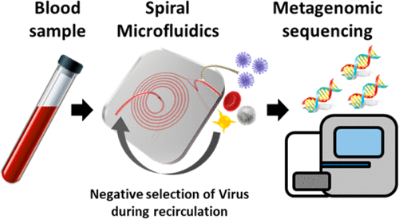

А B C

The figure is prepared by the authors **/** Рисунок подготовлен авторами

The figure is prepared by the authors using their own data / Рисунок подготовлен авторами по собственным данным

**Fig. 1.** Title of the picture in English. a, description; b, description; c, description.

**Рис. 1.** Название рисунка на русском языке. A – обозначение; B – обозначение; C – обозначение.

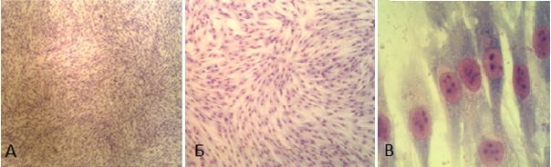

B

A

C

Фотография выполнена авторами / The photograph is taken by the authors

**Fig. 2.** DF-2 cell culture. Romanovsky-Giemsa staining: A, ×40 magnification; B, ×100 magnification; C, ×1000 magnification (oil immersion).

**Рис. 2.** Культура клеток DF-2. Окраска по Романовскому-Гимзе: A – увеличение ×40; B – увеличение ×100; C – увеличение ×1000 (масляная иммерсия).

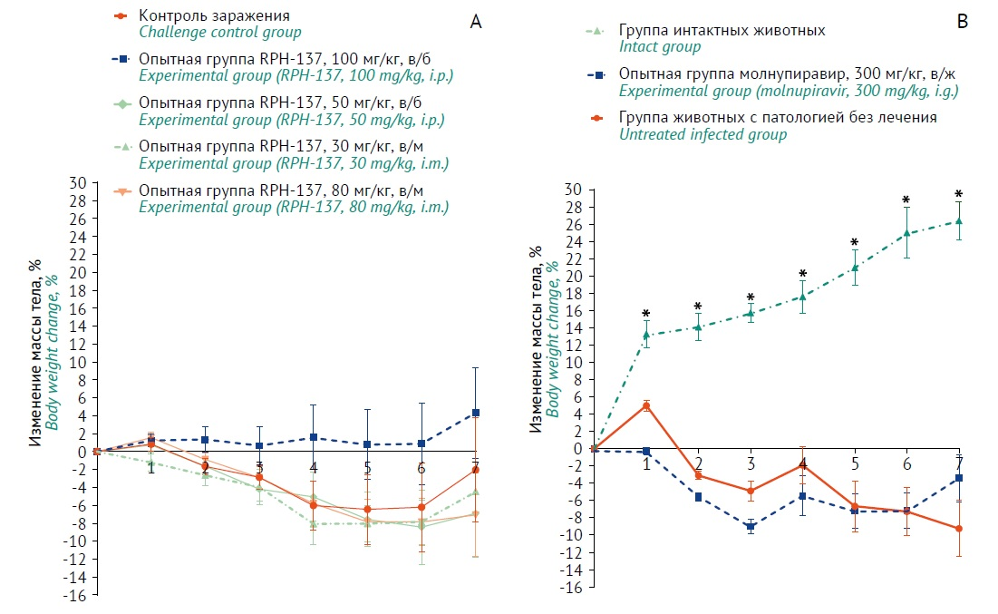

Рисунок подготовлен авторами / The figure is prepared by the authors

Рисунок подготовлен авторами по собственным данным / The figure is prepared by the authors using their own data

**Fig. 3.** Changes in animal body weight starting from the infection day in experiments with RPH-137 (A) and molnupiravir (B). All data are presented as means and standard errors of the mean (M±SEM). The X-axis indicates days after infection. Intact animals: n=6 (days 0–3) and n=3 (days 4–7). Experimental and control groups: n=16 (days 0–3) and n=8 (days 4–7). Asterisks (*) mark statistically significant differences from the corresponding control group, p<0.05 (two-way ANOVA, Dunnett’s test). The legend shows animal groups, test item doses, and administration routes (i.p., intraperitoneal; i.m., intramuscular; i.g., intragastric).

**Рис. 3.** Изменение массы тела животных от момента заражения при проведении экспериментов с введением RPH-137 (А) и молнупиравира (В). Данные представлены в виде среднего арифметического и стандартной ошибки среднего (*M*±*SEM)*. По оси *Х* обозначены сутки от момента заражения. Количество животных в интактной группе: *n*=6 (с 0 по 3 сут) и *n*=3 (с 4 по 7 сут); в опытных и контрольных группах: *n*=16 (c 0 по 3 сут) и *n*=8 (с 4 по 7 сут). * – отличия статистически значимы с группой контроля заражения, *p*<0,05 (two-way ANOVA, критерий Даннета). В легенде представлены группы животных, дозы исследуемых препаратов и способ их введения (в/б – внутрибрюшинно; в/м – внутримышечно; в/ж – внутрижелудочно).

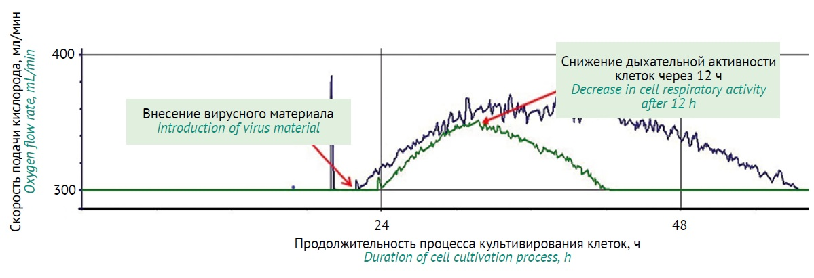Рисунок подготовлен авторами / The figure is prepared by the authors

Рисунок подготовлен авторами по собственным данным / The figure is prepared by the authors using their own data

**Fig. 4.** Oxygen supply rate during the culture process at the viral inoculum introduction stage. The green curve indicates complete infection of cells by the viral inoculum (optimal productivity and virus harvest); the blue one shows incomplete infection of cells by the viral inoculum (low productivity and virus harvest).

**Рис. 4.** Скорость подачи кислорода в ходе процесса культивирования на этапе внесения вирусного инокулята. Кривая зеленого цвета – полное заражение клеток вирусным инокулятом, оптимальная продуктивность наработки вируса; кривая синего цвета – неполное заражение клеток вирусным инокулятом, низкая продуктивность наработки вируса.



Рисунок подготовлен авторами / The figure is prepared by the authors

Рисунок подготовлен авторами по собственным данным / The figure is prepared by the authors using their own data

**Fig.** **5.** Complete scheme of the study of elevated temperature effects on the reference standard of *M. arginini* G230 (batch 9/2).

**Рис. 5.** Полная схема исследования влияния повышенных температур на стандартный образец тест-штамма *М. arginini* G230 (серия 9/2).

The authors should identify patterns in the study results rather than retell the contents of tables and figures.

**CONCLUSION**

The content of this section should correspond to the aim of the study and demonstrate that it has been achieved.

The conclusion should briefly describe the results obtained. The authors should summarise their work, highlighting its theoretical and practical significance. It is advisable to make recommendations for further research in the field.

The conclusion should not repeat the text of the paper word for word. This section may be formatted as a numbered list of conclusions (3–5 bullet points). In this case, its title should be changed to **CONCLUSIONS**.

**References / Литература**

1. Алпатова НА, Гайдерова ЛА, Яковлев АК, Мотузова ЕВ, Лысикова СЛ, Солдатов АА и др. Особенности определения специфической активности биотехнологических лекарственных средств. *Биопрепараты. Профилактика, диагностика, лечение.* 2017;17(1):13–26.

Alpatova NA, Gayderova LA, Yakovlev AK, Motuzova EV, Lysikova SL, Soldatov AA et al. Assessment of biotechnological products’ specific activity. *BIOpreparations. Prevention, Diagnosis, Treatment.* 2017;17(1):13–26 (In Russ.). EDN: [YHSSGL](https://elibrary.ru/yhssgl)

2. Prior S, Metcalfe C, Hufton SE, [Wadhwa](https://www.nature.com/articles/s41587-021-00848-0#auth-Meenu-Wadhwa) M, [Schneider](https://www.nature.com/articles/s41587-021-00848-0#auth-Christian_K_-Schneider) CK, [Burns](https://www.nature.com/articles/s41587-021-00848-0#auth-Chris-Burns) C. Maintaining standards for biosimilar monoclonal antibodies. *Nat Biotechnol*. 2021;39(3):276–280. <https://doi.org/10.1038/s41587-021-00848-0>

3. [Wadhwa](https://www.ncbi.nlm.nih.gov/pubmed/?term=Wadhwa%20M%5BAuthor%5D&cauthor=true&cauthor_uid=33936049) M, [Bird](https://www.ncbi.nlm.nih.gov/pubmed/?term=Bird%20C%5BAuthor%5D&cauthor=true&cauthor_uid=33936049) C, [Atkinson](https://www.ncbi.nlm.nih.gov/pubmed/?term=Atkinson%20E%5BAuthor%5D&cauthor=true&cauthor_uid=33936049) E,[Cludts](https://www.ncbi.nlm.nih.gov/pubmed/?term=Cludts%20I%5BAuthor%5D&cauthor=true&cauthor_uid=33936049) I, [Rigsby](https://www.ncbi.nlm.nih.gov/pubmed/?term=Rigsby%20P%5BAuthor%5D&cauthor=true&cauthor_uid=33936049) P. The first WHO international standard for adalimumab: dual role in bioactivity and therapeutic drug monitoring. [*Front Immunol.*](https://www.ncbi.nlm.nih.gov/pmc/articles/PMC8082443/) 2021;12:636420. <https://doi.org/10.3389/fimmu.2021.636420>

4. Schasfoort RBM. *Handbook of surface plasmon resonance*. 2nd ed. RSC Publishing; 2017.

<https://doi.org/doi:10.1039/9781788010283-FP001>

5. Щелкунов СН, Сергеев АА, Кабанов АС, Якубицкий СН, Бауэр ТВ, Пьянков СА. Патогенность и иммуногенность вариантов вируса осповакцины при разных способах их введения мышам. Инфекция и иммунитет. 2021;11(2):357–64.

Shchelkunov SN, Sergeev AA, Kabanov AS, Yakubitsky SN, Bauer TV, Pyankov SA. Route-coupled pathogenicity and immunogenicity of vaccinia virus variant inoculated mice. Russian Journal of Infection and Immunity. 2021;11(2):357–64 (In Russ.). <https://doi.org/10.15789/2220-7619-PAI-1375>

6. Васин АВ, Егоров АЮ, Сергеева МВ, Стукова МА. Рекомбинантные векторные конструкции на основе аттенуированного вируса гриппа для разработки вакцин против респираторных инфекций. В кн.: [*III объединенный научный форум физиологов, биохимиков и молекулярных биологов*](https://www.elibrary.ru/item.asp?id=49822670&selid=49824067)*. VII съезд биохимиков России. X Российский симпозиум «Белки и пептиды». VII съезд физиологов СНГ*. Т. 2. Москва: Перо; 2021. С. 229–30.

Vasin AV, Egorov AYu, Sergeeva MV, Stukova MA. Recombinant vector constructs based on attenuated influenza virus for the development of vaccines against respiratory infections. In: *III Joint Scientific Forum of Physiologists, Biochemists and Molecular Biologists. VII Congress of Russian Biochemists. X Russian Symposium “Proteins and Peptides”. VII Congress of CIS Physiologists*. Vol. 2. Moscow: Pero; 2021. P. 229–30 (In Russ.). EDN: [SXYWDM](https://elibrary.ru/sxywdm)

7. Carlton RM. Phage therapy: past history and future prospects. *Arch Immunol Ther Exp*. 1999;47(5):267–74. PMID: 10604231

**Additional information.** The authors may provide a link to supplementary materials to the paper (figures, tables, and other files), including those placed in a repository (with their digital object identifiers (DOIs)).

|  |  |
| --- | --- |
| **Authors’ contributions.** All the authors confirm that they meet the ICMJE criteria for authorship. The most significant contributions were as follows. ***E.V. Ivanova*** conceptualised the study, drafted the manuscript, formulated the conclusions, etc. ***M.A. Petrova*** worked with literature sources, etc. ***M.N. Smirnova*** carried out experiments, etc. ***V.G. Sidorov*** participated in formulating the conclusions and approved the final version of the manuscript for publication. | **Вклад авторов.** Все авторы подтверждают соответствие своего авторства критериям ICMJE. Наибольший вклад распределен следующим образом: ***Е.В. Иванова*** – концепция работы, написание текста рукописи, формулировка выводов, и др.; ***М.А. Петрова*** – работа с источниками литературы, и др.; ***М.Н. Смирнова*** –проведение эксперимента; ***В.Г. Сидоров* –** участие в формулировке выводов, утверждение окончательной версии рукописи для публикации. |

**Ethics approval.** The authors should include a statement that confirms that the study was approved (or granted exemption) at a meeting of the institutional research ethics (bioethics) committee, including the reference number of the approval. If the study did not require ethics approval, the authors this should include a statement to that effect.

EXAMPLES:

|  |  |
| --- | --- |
| **Ethics approval.** The Bioethics Committee at the [*organisation*] approved the study under meeting minutes No(s). _____.  _____. | **Соответствие принципам этики.** Исследование было одобрено на заседании биоэтической комиссии «Название организации», протокол заседания № |
| **Ethics approval.** The study was conducted in full compliance with the ethical principles for medical research involving human subjects described in the Declaration of Helsinki. According to the authors, the analysis was based on previously published anonymised data, and the study did not involve any direct participation of human subjects. Hence, this study was exempt from ethics approval. | **Соответствие принципам этики.** Исследование проводилось в соответствии с этическими принципами медицинских исследований с участием человека, изложенными в Хельсинкской декларации. Авторы заявляют, что одобрение комитетом по этике не требовалось, поскольку проанализированные данные были основаны на ранее опубликованных обезличенных данных, и в исследовании непосредственно не участвовали люди. |

**Acknowledgments.** The authors may use this section to thank others for their help with accessing databases, literature sources, etc. The authors may express gratitude to the colleagues who assisted in the study or provided critical feedback on the manuscript. However, the authors should first obtain permission from the people or institutions they would like to address.

EXAMPLES:

|  |  |
| --- | --- |
| **Acknowledgements.** The authors express their gratitude to I.I. Ivanov for valuable advice when discussing the study results, to City Hospital No. 3 for granting access to the patient information base, and to Medical University No. 4 for the opportunity to use the Shared Core Facilities and for help with NMR experiments. | **Благодарности.** Коллектив авторов благодарит Иванова И.И. за ценные консультации при обсуждении результатов работ, ГБОУЗ «Третья городская больница» за предоставление доступа к базе данных пациентов, ФГОУ ВО «Четвертый медицинский» за предоставление возможности работы в специальной библиотеке учреждения. |

**AUTHORS / ОБ АВТОРАХ**

|  |  |
| --- | --- |
| **Elena V. Ivanova,** academic degree, academic status in English  ORCID:https://orcid.org/0000-0000-0000-0000 (or the RISC SPIN-code, Scopus Author ID, Web of Science Researcher ID) | **Иванова Елена Владимировна**, ученая степень, ученое звание  ORCID:https://orcid.org/0000-0000-0000-0000 (или SPIN-код РИНЦ, Scopus, ResearcherID) |
| *(For each author)* | *(Привести данные для каждого автора)* |

For more information on formatting, see the Author Guidelines <https://www.biopreparations.ru/jour/about/submissions#authorGuidelines>

1. Document title and reference, e.g. OFS.1.2.4.0002.18 Microbiological Quality. State Pharmacopoeia of the Russian Federation, ed. X, v. 1. M.; 2018.